# Line Chart

## Found At:

<http://richhildebrand.github.io/Jason-Kipnis/lineGraph.html>



## Adjust graphed data:

Choose the type of data you would like to graph from the dropdown.

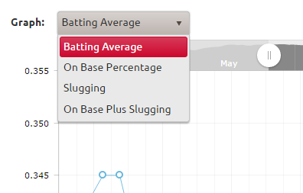

## Adjust the display area:

#### Method 1

Click along the top bar of the graph and the display area will shift to show you the clicked point.

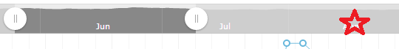

#### Method 2

Click and hold the mouse in the middle of the bar and drag the shown area to the desired location



## Various ways to zoom:

#### Method 1

Click on the graph and drag your mouse to zoom into a section.

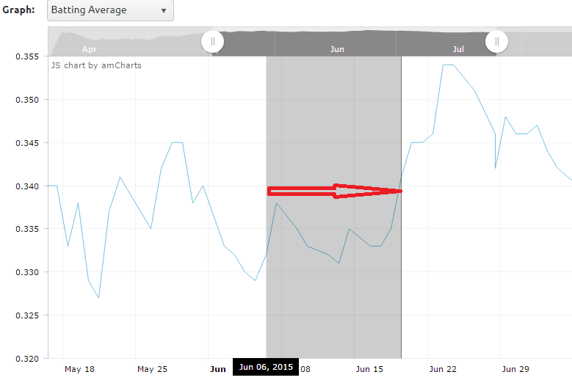

#### Method 2

Drag one of the handles.

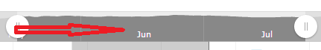

#### Method 3

Scroll the mouse wheel over the graph.

#### Method 4

Zoom all the way out by clicking “Show All”

